RFP #26-10 ANIMAL SERVICES CARE & CONTROL FACILITY
Addendum #1:
Posted: 1/9/2026

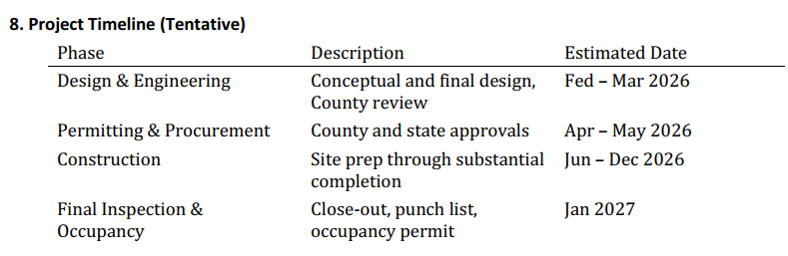
- We reviewed the recent RFP posted for DB Services for Butts County Animal Services Care & Control Facility Projects and have a quick question. If known, what is the expected start date for construction? Once the contract has been signed and approved by the BOC (February 2026), the project will be ready to proceed. Check page 12 for the Project Tentative Timeline.

- Will the facility have an oxygen generator and additional gas piping? Yes
- Will the facility need a Generator? Yes
- Will the facility need operating rooms? Yes
- For the PEMB, will we get the reactions beforehand or do we need to assume and verify the foundations later? Assume and document in proposal.
- Do we have a geo-technical report for the site? If not our proposal will assume normal soil conditions and the foundations will be shallow spread footings – We have not completed any testing, therefore I suggest any outside considerations or concerns be itemized if not included in proposal for total clarification.
- Typical animal housing will require masonry walls cladded with tiles (in the Kennel and Cat housing areas) which is total of 50 enclosures – we will need to engineer all of the walls as well – We expect business standards compliant with best practices for animal facilities. Outline and considerations should be included in proposal.

