ITB #26-09 FIRE APPARATUS
Addendum #2:
Posted: January 9, 2026

- Do you have the exact paint scheme for the apparatus? The only thing that would be different is the Butts County Fire Department would be Butts County Fire and Emergency Services

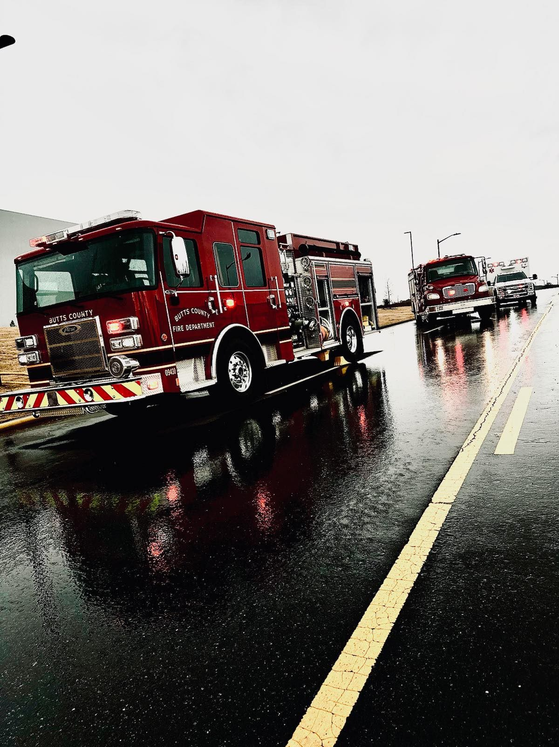

- What is the budget for the project? The total budget is 1,100,000.00
- Would you consider a truck that is currently in production and would be available by late spring/ early summer 2026? It meets most, if not all, of the specifications and will be ready in months, not years. Yes, this could be a consideration. Details of what is available should be listed. However, they would have to meet indicated specifications or explain the difference.
- Taking delivery of this truck, currently in production, will have a Cummins L9, not the new Cummins X10, saving Butts Co over $30K. Yes, this motor is an option. The truck options will need to be as listed in vehicle specifications.
- Pg 17, sect. L. Interior Installations- is this from ambulance template and should be disregarded? Addendum #1 clearly states to disregard pages 17 & 18 as they were added in error.

