Addendum #3
BID #25-09 Roof replacement

- We have received many questions from vendors who did not attend the mandatory pre-bid meeting. Please understand that if you did not have a representative in attendance that day, your submitted BID will not qualify for consideration.
- I see that addendum 2 just came out. It mentions that we will be doing a recover NOT a tear off. Can you please specify exactly what roof recover system should be priced? There are dozens of different options to recover a roof. We will need to know exactly what type of coverboard (Polyiso, dens deck?) and what thickness it should be (1/2”, 1”, 1.5”?). Also, what TPO membrane thickness? I’m assuming 60 mil TPO. (most common and meets 20-year warranty minimum). We are not roofing experts. We have put out our needs and scheduled the pre-bid meeting so the experts could determine what was needed and tell us the best solution. The drone evaluation was suggested, so we had that done. But if areas are holding water or are damaged and need the tear-off, you as the expert will need to let us know the best solution.

- I also want to confirm that we are excluding the 2 small existing metal roof areas, correct? Red X’s below indicate areas that are excluded.
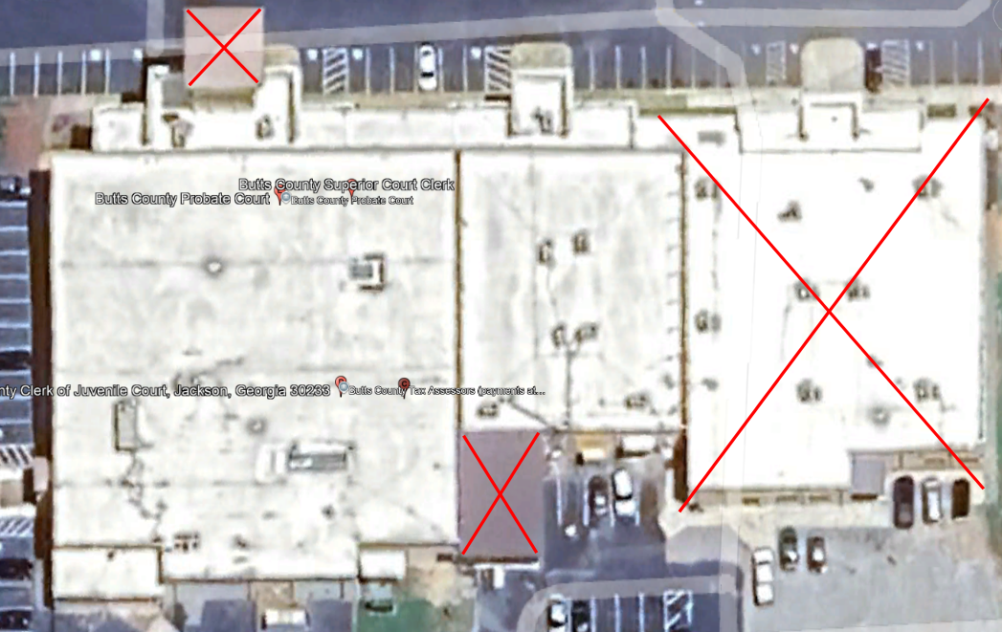
This is correct. The metal roof portions are not included in this BID.
- Most IR moisture scans give percentages that tell how much of the roof is actually suspected to be wet. The report I saw for this did not include that info. If we are planning to recover as y’all mentioned, we just need to know the exact roof system to price. A common and cost-effective roof recover system would be mechanically attaching 1 layer of 1” polyiso insulation. Then mechanically attaching 60 mil TPO in order to get a 20-year NDL manufacturer’s warranty. (1.5” polyiso could be used if desired by Butts County in lieu of 1”polyiso). We suggest that your BID includes the “standard” used materials for the 20-year warranty. As for the percentage of wetness, the report was sent out as we received it.

